**Assignment 5 GridView**

The GridView control is used to display the values of a data source in a table where each column represents a field, and each row represents a record. To help you understand the GridView control, I want you to complete the blanks in the following table and make a program following Step 4.

1. **Attributes of the GridView Control**

|  |  |
| --- | --- |
| **Attributes** | **Description** |
| Caption | Gets or sets the text to render in an HTML caption element in a GridView control. This property is provided to make the control more accessible to users of assistive technology devices |
| CaptionAlign | One of the TableCaptionAlign values. The default is TableCaptionAlign.NotSet, which uses the browser's default setting. |
| GridLines | Gets or sets the gridline style for a GridView control |
| AllowSorting | Gets or sets a value indicating whether the sorting feature is enabled |
| AutoGenerateColumns | Gets or sets a value indicating whether bound fields are automatically created for each field in the data source |
| AutoGenerateDeleteButton | Gets or sets a value indicating whether a CommandField field column with a Delete button for each data row is automatically added to a GridView control |
| AutoGenerateEditButton | Gets or sets a value indicating whether a CommandField field column with an Edit button for each data row is automatically added to a GridView control |
| AutoGenerateSelectButton | Gets or sets a value indicating whether a CommandField field column with a Select button for each data row is automatically added to a GridView control |
| AllowPaging | Gets or sets a value indicating whether the paging feature is enabled |
| PageIndex | Gets or sets the index of the currently displayed page |
| PageSize | Gets or sets the number of records to display on a page in a GridView control |
| EnableSortingAndPagingCallbacks | Gets or sets a value indicating whether client-side callbacks are used for sorting and paging operations |
| DataKeyNames | Gets or sets an array that contains the names of the primary key fields for the items displayed in a GridView control |
| DataMember | Gets or sets the name of the list or table in the data source for which the DataGridView is displaying data |
| DataSourceID | Binds the data source to the GridView control. This method cannot be inherited |

1. **Attributes of the PagerSettings Class**

|  |  |
| --- | --- |
| **Attributes** | **Description** |
| Mode | Gets or sets the mode in which to display the pager controls in a control that supports pagination. |
| FirstPageImageUrl | Gets or sets the URL to an image to display for the first-page button. |
| FirstPageText | Gets or sets the text to display for the first-page button |
| LastPageImageUrl | Gets or sets the URL to an image to display for the last-page button. |
| LastPageText | Gets or sets the text to display for the last-page button. |
| NextPageImageUrl | Gets or sets the URL to an image to display for the next-page button. |
| NextPageText | Gets or sets the text to display for the next-page button. |
| PreviousPageImageUrl | Gets or sets the URL to an image to display for the previous-page button. |
| PreviousPageText | Gets or sets the text to display for the previous page button. |
| PageButtonCount | Gets or sets the number of page buttons to display in the pager when the Mode property is set to the Numeric or NumericFirstLast value. |
| Position | Gets or sets a value that specifies the location where the pager is displayed. |

1. **GridView Events**

|  |  |
| --- | --- |
| **Events** | **Description** |
| PageIndexChainged | Occurs when one of the pager buttons is clicked, but after the GridView control handles the paging operation |
| PageIndexChainging | Occurs when one of the pager buttons is clicked, but before the GridView control handles the paging operation. |
| Sorted | Occurs when the hyperlink to sort a column is clicked, but after the GridView control handles the sort operation. |
| Sorting | Occurs when the hyperlink to sort a column is clicked, but before the GridView control handles the sort operation |
| SelectedIndexChanged | Occurs when a row's Select button is clicked, but after the GridView control handles the select operation. |
| SelectedIndexChanging | Occurs when a row's Select button is clicked, but before the GridView control handles the select operation. |
| RowEditing | Occurs when a row's Edit button is clicked, but before the GridView control enters edit mode |
| RowUpdated | Occurs when a row's Update button is clicked, but after the GridView control updates the row |
| RowUpdating | Occurs when a row's Update button is clicked, but before the GridView control updates the row |
| RowDeleted | Occurs when a row's Delete button is clicked, but after the GridView control deletes the row. |
| RowDeleting | Occurs when a row's Delete button is clicked, but before the GridView control deletes the row. |
| RowCommand | Occurs when a button is clicked in a GridView control. |
| RowDataBound | Occurs when a data row is bound to data in a GridView control. |

1. **Coding**

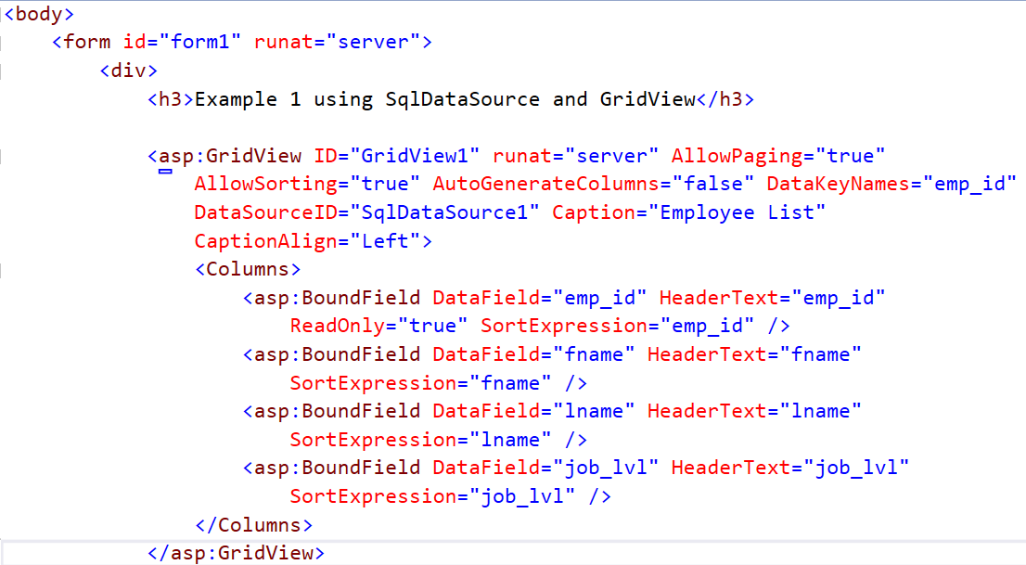

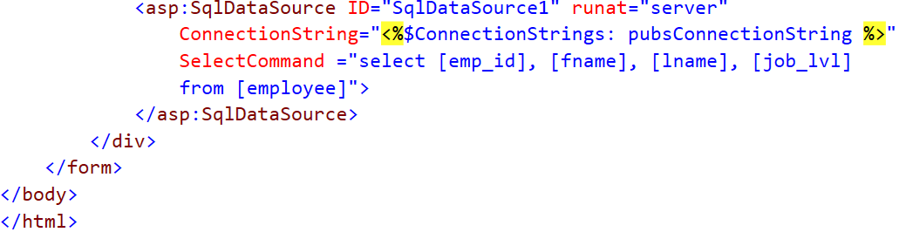

1. **Output**

